# **PEEE I Practical Session 5**

Series DC Circuit

________________________________________________________________________

**1. OBJECTIVE**

* To verify that voltages and current in a given series dc circuit obey Ohm’s law, Kirchhoff’s voltage law and the voltage divider rule.

**2. EQUIPMENT**

* DC power supply
* Digital Multimeters (DMMs)
* Training kit with 1.0 k 3.3 k  k and  k resistors

**3. PROCEDURE**

3.1 Use **resistor colour codes** to identify the 1 k 3.3 k  k and  k resistors on the transparent component board (training kit).

**Do not rely** on the resistor **labels** on the component board to identify these 4 resistors.

**Do not connect** the **circuit** in Figure 5.1 now.

3.2 Pick up the **DMM** with the label, Voltmeter, printed on top of it, and turn its **rotary switch to ‘'** to measure resistance. **Connect the DMM across *R*1** to measure the actual resistance of *R*1. **Fill in** your measured resistance in **Column B** of **Table 5.1**.

 Repeat step 3.2 to measure and record the actual resistances of *R*2, *R*3 and *R*4 in Table 5.1.

HBL note: 3.2 and 3.3 has been done for you.

|  |  |  |
| --- | --- | --- |
| *A* | *B* | *C* |
| Nominal Resistance indicated by colour code | Actual/Measured Resistance | Resistance calculated by using measured voltage, measured current, and Ohm’s law |
| *R*1  1.0 kΩ | *R*1 = *0.998* kΩ | *R*ab = *V*ab / *I* = kΩ |
| *R*2 3.3 kΩ | *R*2 = *3.332* kΩ | *R*bc = *V*bc / *I* = kΩ |
| *R*3  6.8 kΩ | *R*3 = *6.79* kΩ | *R*cd = *V*cd / *I* = kΩ |
| *R*4  10 kΩ | *R*4 = *10.02* kΩ | *R*de = *V*de / *I* = kΩ |
| ― | *R*1 + *R*2 + *R*3 = kΩ | *R*ad = *V*ad / *I* = kΩ |
| ― | *R*2 + *R*3 = kΩ | *R*bd = *V*bd / *I* = kΩ |
| Are the calculated resistances using Ohm’s law in Column C close to the actual resistances in Column B?  Yes / No (Circle your answer) | | |

# Table 5.1

Do not connect the circuit in Figure 5.1 now. Follow steps 3.1 to 3.4 to fill in Column B.

Before filling in Column C, follow steps 3.5 to 3.13 to fill in Table 5.2 first.

 **Calculate** ***R*1 + *R*2 + *R*3** and ***R*2 + *R*3** with the **measured resistances**. Fill in your answers in Table 5.1.

**Note:**

The actual resistance should be within the manufacturing tolerance. For example, a gold coloured tolerance band indicates a tolerance range of ±5%. 1 k ±5% is a resistance range of 950  to 1050 .

3.5 Skip filling in the rest of Table 5.1 after completing Column B.

3.6 Connect the circuit as shown in Figure 5.1.

Figure 5.1 A series circuit

e

d

c

b

a

*I*

*I*

*R*4

10 kΩ

*R*3

6.8 kΩ

*R*2

3.3 kΩ

*R*1

1.0 kΩ

−

+

μA

−

+

**V**

*V*S

≈ 5 V

−

+

HBL note: Construct the above circuit using Multisim e.g. as shown in Figure 5.1a. It does not matter if your circuit looks different from Figure 5.1a, as long as all the components are there.

(The steps are similar to what you did in Practical Session 4. Please refer to Practical Session 4, if necessary.)

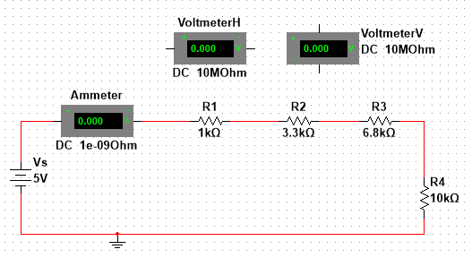

Figure 5.1a

1 Measure the current and voltages as required, and fill up Table 5.2. You will need to connect and disconnect the Voltmeter several times, in order to measure all the voltages required in order to fill up Table 5.2. A couple of examples are shown.Figures 5.1b to 5.1c below.

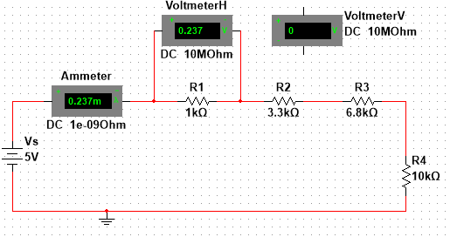

Figure 5.1b Measuring the Current *I*, and Voltage *V*ab

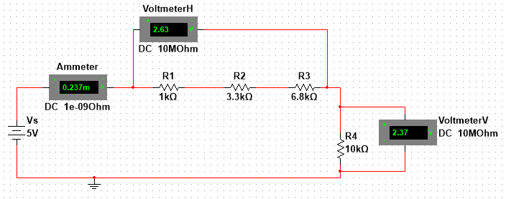

Figure 5.1c Measuring the Current *I*, Voltage *V*ad and Voltage *V*de

**Note that the part in green (for HBL) replaces 3.1 to 3.3 and 3.5 to 3.13 of this Practical. You still have to do 3.4 and 3.14 onwards, using the data from Mutlisim.**

3.7 Set the dc power **supply voltage *V*S** to about **5 V**.

3.8 Connect the **DMM** **labelled ‘Voltmeter’** across the power supply to measure the **supply voltage *V*S**. Turn the **rotary switch** of the DMM to **Volt dc, ‘V**⎓**’**. Record your measurement in Table 5.2. Keep the supply voltage unchanged throughout the experiment.

3.9 Use the other **DMM** labelled **‘Ammeter’** to measure the **current *I*** flowing through the series circuit. Turn the **rotary switch** to **μA dc, ‘μA**⎓**’**. Record the current value in Table 5.2.

3.10 Disconnect the ***voltmeter*** from the circuit but keep all other parts of the circuit connected.

3.11 Connect the **red +ve probe** of the ***voltmeter*** to **point ‘a’** of the circuit, and connect the **black −ve probe** from the ‘COM’ socket of the voltmeter to **point ‘b’** of the circuit.

3.12 Measure and record voltage *V*ab in Table 5.2.

3.13 Repeat steps 3.10 to 3.12 to measure and record all the other voltages in Table 5.2.

Convert meter reading from μA to mA.

|  |  |  |
| --- | --- | --- |
| Supply Voltage *V*S = |  | ______________ V |
| Current *I* = |  | ______________ mA |
| Voltage *V*ab = |  | ______________ V |
| Voltage *V*bc  = |  | ______________ V |
| Voltage *V*cd = |  | ______________ V |
| Voltage *V*de = |  | ______________ V |
|  |  |  |
| Voltage *V*ad = |  | ______________ V |
| Voltage *V*bd  = |  | ______________ V |

# Table 5.2

3.14 Check whether the measured resistances, voltages and currents obey Ohm’s law.

**Complete Table 5.1** using the measured values in Table 5.2.

**Note:**

The **accuracy** of the **DMM** to measure resistance, voltage and current are **about ±1%**.

Therefore, the accuracy of the measured resistances in Column B is about ±1%.

The percentage error of the calculated resistance in Column C = Percentage error of the voltage measurement + Percentage error of the current measurement. That is about 2% in total.

Although the resistance values in both Column B and Column C should be very close to the actual resistances, the **direct measurement** values in Column B should be **more accurate**.

In the PEEE experiments, you can assume that the DMM resistance measurements are accurate.  
You can also safely assume that the **internal resistance** of the **ammeter** is equal to **zero**. Therefore, *R*1 = *R*ab, and *R*1 + *R*2 + *R*3 = *R*ad theoretically.

3.15 Check whether the measured voltages obey Kirchhoff’s Voltage Law (KVL).

The following equation is written by applying KVL in the series circuit in Figure 5.1.

$$V_{T}=V_{1}+V_{2}+V_{3}$$

Fill in Table 5.3 according to the measured voltages recorded in Table 5.2.

|  |
| --- |
| Total voltage rise = *V*S = ____________ V |
| Total voltage drop = *V*ab + *V*bc + *V*cd + *V*de = ____________ V |
| Do the total voltage rise and the total voltage drop obey Kirchhoff’s voltage law?  Yes / No (Circle your answer) |

# Table 5.3

3.16 Check whether the measured resistances and voltages obey the Voltage Divider Rule (VDR).

**Copy** the measured voltages of *V*ad and *V*bd **from** **Table 5.2** to Column A of Table 5.4.

**Calculate** *V*ad and *V*bd using the voltage divider rule. **Use** the **measured resistances** in **Table 5.1** and the **measured supply voltage** in **Table 5.2** for your calculation. Compare the measured *V*ad and *V*bd with the calculated values.

|  |  |  |
| --- | --- | --- |
| Voltage | *A* | *B* |
| Measured Value in Table 5.2 | Calculated Value using VDR |
| *V*ad |  |  |
| *V*bd |  |  |
| Does the voltage divider rule give answers close to the measured values?  Yes / No (Circle your answer) | | |

Table 5.4

**Note:**

Calculations in Column B are based on multiple measured values. Therefore, the **direct measurements** of *V*ad and *V*bd in **Column A** are **more accurate** than the calculated values in Column B.

|  |  |
| --- | --- |
|  | Does the inclusion of the microammeter (DMM set to current mode) in the circuit affect the voltage and current measurements significantly? (Yes/No). Briefly explain your answer.  If an ammeter is wrongly connected in parallel with a resistor, what will be the voltage across the resistor?  ____________________________________________________________  ____________________________________________________________  ____________________________________________________________  ____________________________________________________________  ____________________________________________________________ |

###### **4. DISCUSSION**

* 1. The current in the series circuit is ____________________ throughout the circuit because there is only _______ path in the circuit.
  2. In the series circuit, the total voltage rise is equal to

This agrees with _________________________ law.

* 1. Calculate the total resistance of the series circuit.

* 1. Use the voltage divider rule to write an equation to calculate the voltage across *R*4.

**5. CONCLUSION**

The results of this experiment were found to obey the following circuit laws and rules: